Kaylee Hansen
June 15, 2025
Professional Persona Executive Summary
Introduction
Over the past three years of completing my degree while working full time, I have grown in many ways. This course, along with my leadership experience as an Insurance Analyst at Nationwide, gave me the opportunity to better understand how others view me professionally. By examining a self-assessment and Professional Reputation Survey, I’ve developed a more balanced picture of my performance and persona. This summary reviews how that feedback aligns or contrasts with how I see myself, and how I plan to use that insight to grow.
Core Values
The values I selected for myself include being empathetic, caring, growth oriented, hardworking, and trustworthy. Survey respondents used similar traits such as calm, driven, involved, perfectionistic, and leaderlike. These overlaps confirmed that the way I want to present myself is, for the most part, coming across clearly to others. However, I was surprised that traits like anxious or dwelling on mistakes, how I often feel internally, were not reflected externally. This reminded me that internal self-talk does not always mirror the image others experience.
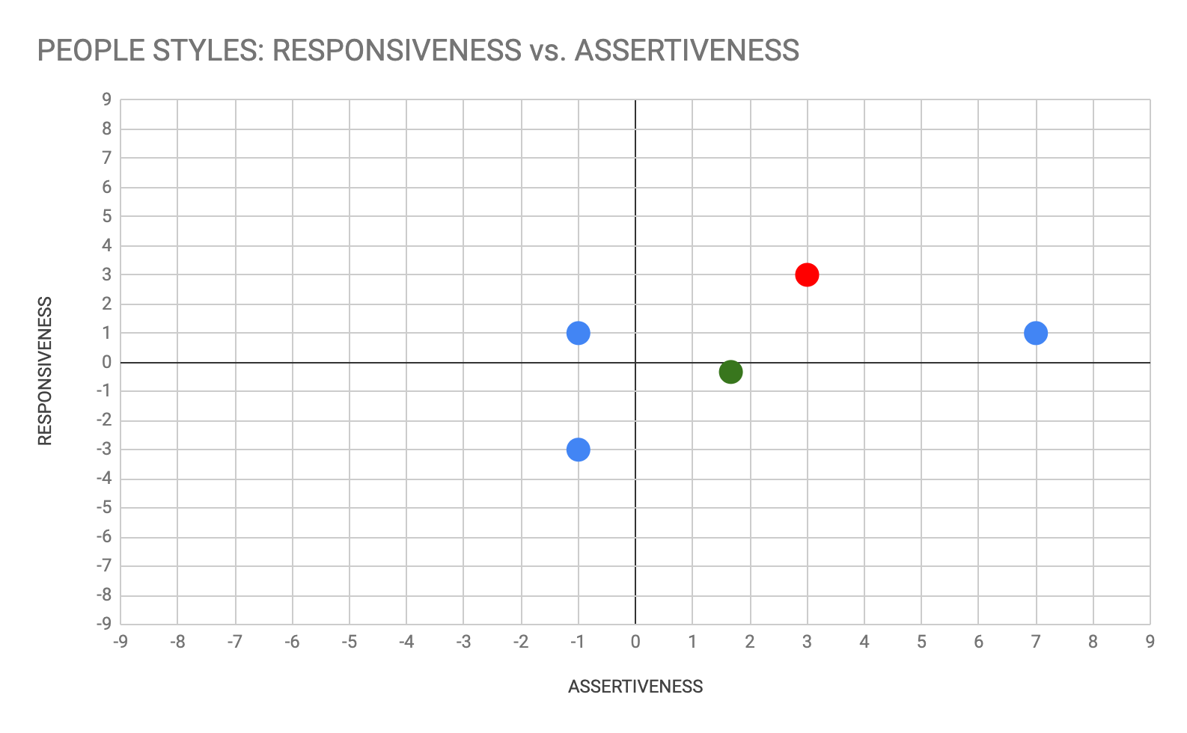
People Style Self-Assessment
According to my People Style results, I fall into the Expressive category with a composite assertiveness score of 3 and a composite responsiveness score of 3. Expressive(s) are known for being involved, outgoing, and idea generators. These traits match how I contribute to group work, lead conversations, and support others. Survey responses were aligned with this, although I sometimes sense that others may see me as more reserved. I recognize my perfectionism, and hard-working nature can lead me to focus on results over relationship building, especially when balancing remote work and school.

External Views
The Professional Reputation Survey provided some open-ended responses that helped me reflect more deeply. One peer described me as calm, reliable, and focused on getting the job done. Another noted that I can sometimes seem too independent and encouraged me to let others assist more. This feedback confirmed that I present as driven and leaderlike but, may unintentionally create distance from others by not being as outwardly responsive or inviting.
Lessons Learned
The most important insight I gained is how different my internal view can be from how I am seen externally. I tend to overthink and be critical of my performance, but others often see someone who is composed, thoughtful, and dependable. Still, I want to be more intentional about how I interact with peers I may not know well. I cannot help but overthink my data and want to adjust into making my experiences with peers I may not be as close to as empathetic and personal so I can continue to grow my network of friends and coworkers.
Conclusion
By evaluating the results from my self-assessment, peer and professor feedback, and the Professional Reputation Survey, I have gained a clearer understanding of how I am perceived and how I want to grow. This process affirmed many of my strengths, such as being driven, caring, and involved, while also pointing to areas where I can improve, like approachability and nonverbal communication. I believe that continuing to reflect, adjust, and engage with intention will help me strengthen my professional persona and relationships moving forward.

